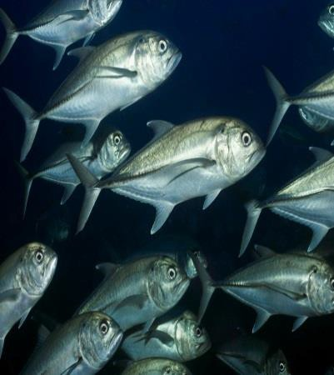





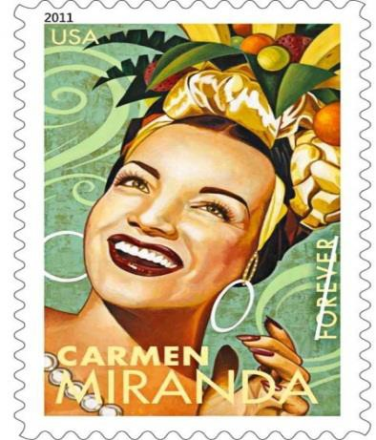
Unit 2 Food
Instructions for Paper 3 Practice Unit (350 pts.)
- Watch a Video on Food Issues – Food, Inc. The student will discuss the presentation of the documentary. What was the objective? How did they get the message across? What made it effective? What were the flaws in the presentation? The class will develop a list (2) 20 pts.
- Discussion on Local to Global Issues – Create a list of local to global issues involving food, diet, and farm practices that are important to your local community. (1) 20 pts.
- Take notes on format for local problem, individual problem, solutions unique and original ideas. (1) 20 pts.
- Select a topic for the group and who is in your group. Notes need to be taken as to how you decided on the topic, the individual question, the members, the global implications (google to see if it is global. Turn in names, topic, individual perspectives, why locally important and also globally important. (2) 20 pts.
- Research the individual perspective – The student must have two reasons for the problem and two examples for each reason. The research must have two local and two global examples. (4) 80 pts.
- Analysis and Evaluation of content – Each example must have analysis and evaluation of content. Two to three sentences total. (2) 40 pts.
- Evidence of source strength - The student will write a lead in to the examples with source evidence. (1) 20 pts.
8. Discussion of Presentation Skills – Students will demonstrate weak and strong video skills by watch A Level student videos and finding them on the internet. (2) 20 pts.
9. Watch the Video - How I Fell in Love with a Fish. Write a review of his presentation style, pictures, and impact of the point. This should include positives and negatives of the presentation. (1) 20 pts.
10. Books The student will start the book of your choice for unit 3. The student will highlight and note take. The student needs to write at least 5 notes (notes are in the form of a question developed) per chapter and 5 highlights (quotes you want to remember for plot development or literary importance, or something you want to remember from the book) per chapter (different if you read A Long Way Gone). You need to read half of the book this unit. If the student is using the paperback the student needs to tab all places in each chapter or list, the highlights and notes per chapter. (5) 50 pts.
11. PowerPoint - The student will create a ten slide ppt on their individual perspectives. The ppt will include images titles, in body citations, 4 graphics, and key words that will emphasize their key points. The final slide will be a references slide. (3) 40 pts.

